RED RIVER COMMUNITY HOUSE
SQUARE & ROUND DANCE SESSIONS
2026 SUMMER SCHEDULE
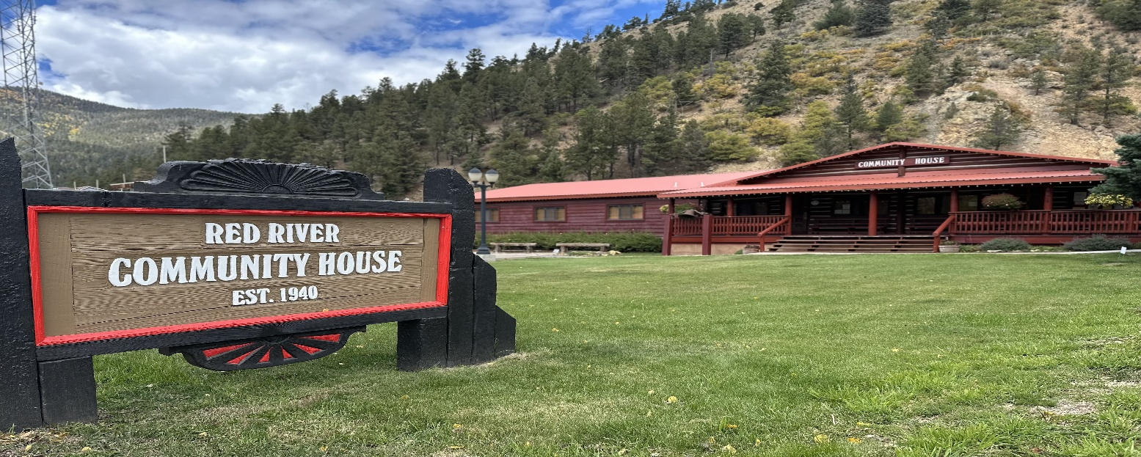

Sat, Mon, Tues - July 11, 13, 14 Toby and Judy Thomason
Sat, Mon, Tues - July 25, 27, 28 Ray and Linda Savell
Thurs, Fri, Sat - August 6, 7, 8 Freddie and Gail McKee
August 6-8 Only Jamie and Dave Sader - Round Dance Cuer

10am-Noon: Beginner, Mainstream & Plus Square Dance Lessons…All Sessions!
7pm-9pm: Square Dancing, Line Dancing, Two Steppin’…All Sessions!
7pm-9pm: Round Dancing (3rd session only, August 6-8)
1:30pm-3:30pm Round Dance Beginner and Intermediate Workshop (3rd session Only, August 6-8)

*Evening meal before the 2nd night of dancing each session (6pm)*
*Ice Cream social after the 3rd night of dancing each session (9pm)*

***No charge for any session, donations are appreciated!***

Enjoy Red River’s fishing, hiking, shopping, dining, horseback rides, chair lift rides and more!

Go to www.redrivercommunityhouse.org for the 2026 schedule of events for the entire family!
116 Main Street, Red River, New Mexico 87558
Phone: 575-754-2349
Email: redrivercommunityhouse1940@gmail.com
Visit www.redriver.org for lodging, restaurants, and adventure activities

